3 - WebApi_Handson
Web Api using custom model class
First, we create a new controller - EmployeeController with Read Write actions.
Then we create a Custom action filter for Authorization.
And lastly, we build Custom Exception filter
INPUT:
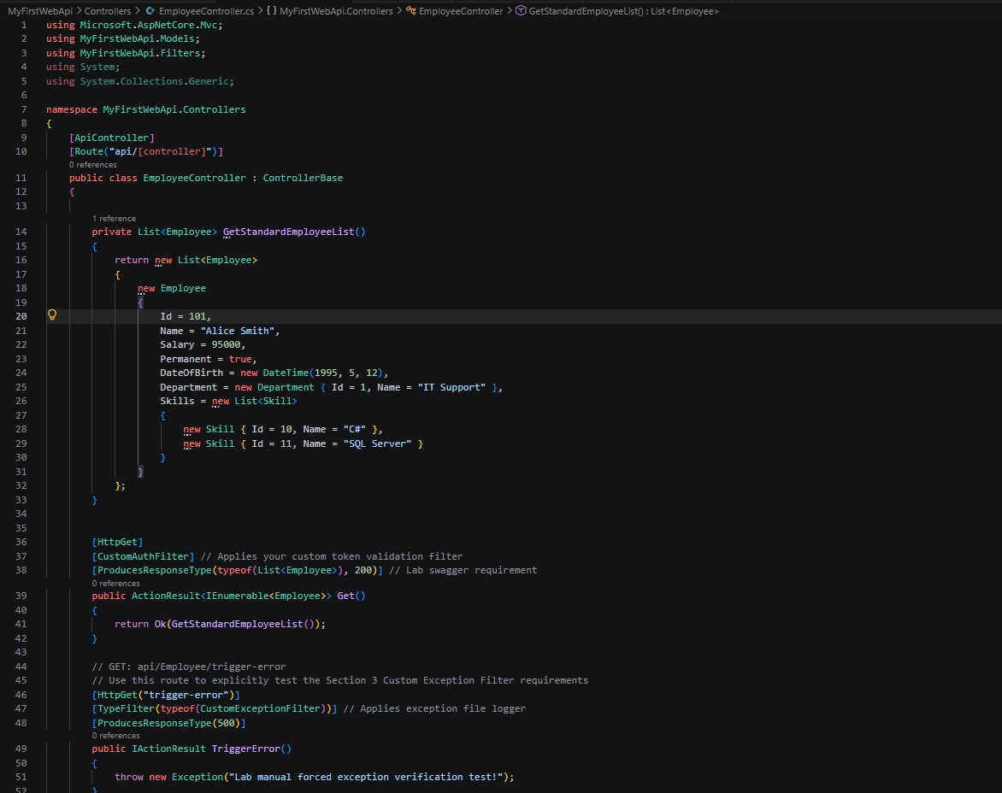
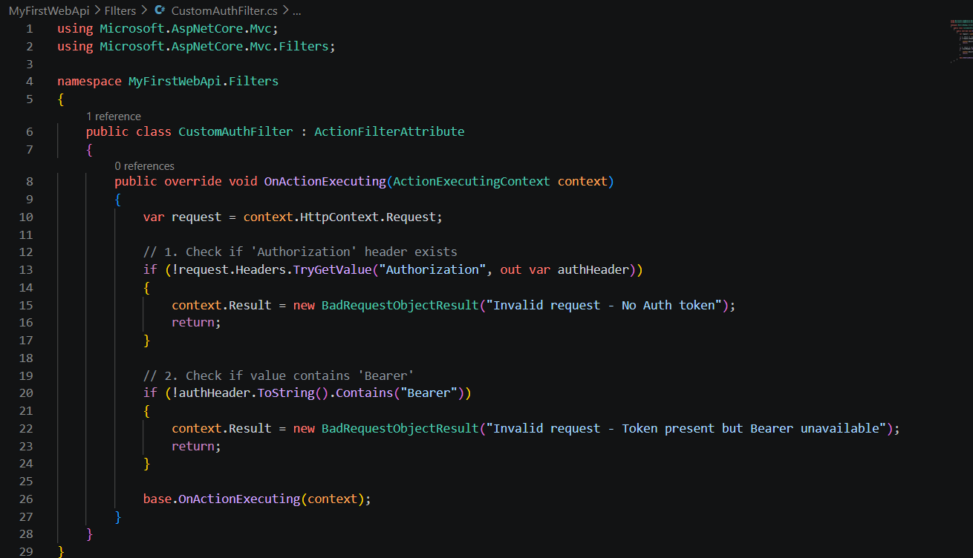
OUTPUT:
